Award Winning Competition Chicken

Technically, chicken is the easiest of the four KCBS categories to cook. The scoring data seems to support that hypothesis. If you look at our stats page for any given year, you’ll see that more unique teams win awards in chicken than any other category. For example, in 2008, 1329 unique teams had a Top 10 finish in Chicken versus 1226 unique teams scoring in brisket and only 1009 unique teams getting a Top 10 overall finish. So chicken should be the best opportunity for a new team to get a call.
However, while those statistics are accurate for the contest circuit as a whole, they mean very little to those of us who have gone through a chicken drought. The Pickled Pig struggled in chicken for a long time. We had a 1st place finish in 2003, a 6th place finish in 2005, and a 2nd place in 2006. That is not good considering we had been doing six or seven contests a year since 2001. During the drought, we tried all kinds of processes, techniques, styles, presentations and flavor profiles and kept changing from contest to contest. About midway through the 2007 season we got serious about competing and started researching how the consistent winners achieved success. And, we started evolving a technique and recipe that was truly our own.
That is not saying we were the first, just that we developed this style internally, borrowing only bits and pieces from a variety of sources. Lately, we have noticed more and more teams doing a similar style so the window of opportunity may be closing. But we too are constantly refining and improving. We already know what is next for our chicken and hopefully we can stay ahead of the curve. As always, once we get a proven track record will be happy to update our published methods.
All of the work seems to be paying off now. Starting half way through last season we finally started getting calls on a consistent basis. In our last 10 contests, we have had 8 Top 10 finishes including 2 first place awards. As of now, it is our best and most consistent entry. When done right, it looks great and tastes even better.
My usual disclaimers apply. Keep in mind The Pickled Pig is not the standard bearer for BBQ chicken. I do not believe this is “the only way” to make contest chicken and it certainly isn’t “the best way” to do it. It is merely an explanation of how we currently do it and the consequential success we have had. There are more successful teams and chicken cooks that must be doing it better (just look at our Power Rankings for a list of those teams). It is my hope that others find this information useful and offer their own experience and expertise up so we all can benefit. So take what you can from this and leave the rest.

Part I – Selection

Breed and Cut
The first thing you have to decide when preparing for contest chicken is what breed and cut(s) you are going to turn in. The relevant KCBS rules for chicken are:
- CHICKEN: Chicken includes Cornish Game Hen and Kosher Chicken.
- Chicken, pork and brisket may be submitted chopped, pulled, sliced, or diced as the cook sees fit, as long as there is enough for six (6) judges.
The modern day chicken is a descendant of the Southeast Asian red jungle fowl first domesticated in India around 2000 B.C. Most of the birds raised for meat in America today are from the Cornish (a British breed) and the White Rock (a breed developed in New England) breeds. We’ve yet to hear of any consistent success with Cornish Game Hens so we stick with ordinary, readily available market chicken (White Rock) for our contest entries.
As you can see from the rules above and the diagram below, there are a lot of options for this category.
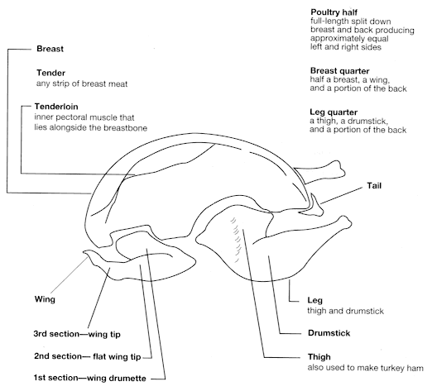
I have sampled breast meat that practically melts in your mouth and has excellent flavor. I have even cooked with someone who turns in breast meat that has several 1st place chicken awards. A few teams are doing very creative things with drums and wings. Occasionally I come across some interesting pulled chicken entries. Many times, I have even seen teams turn in a combo box with drums, breasts, and thighs, giving judges their choice. And I often hear judges complain about getting nothing but thighs at a contest…they long for something different.
Even with all that being said, we use chicken thighs exclusively for our chicken entries. BBQ chicken, in all of its forms, peaks about 5 minutes after you remove it from the cooker. The judges may not eat your entry for 15, 20, or even 30 minutes after you submit it. So while other cuts are great when you first slice into them, they may not be so great when the judges sample them. That juicy breast may dry out and the wing may harden by the time judges get to it. The moist, dark meat thigh seems to hold up the best in the clamshell while waiting to be judged.
Grade
Unlike beef, chicken is rarely graded. USDA grading for chicken is done on a voluntary basis (paid for by the producer) and only three grades are issued, "A", "B" and "C". Since "A" is all that is sold in supermarkets, you needn't be concerned with grading. This is not to say that all chicken will taste the same, just that USDA grading isn't a factor in the selection process. We recommend trying several sources and brands of chicken available in your area in order to make the best possible choice.
Selection Characteristics
Class
The class of poultry indicates the age of the bird. Age affects the tenderness of poultry meat and dictates the cooking method to use for maximum flavor and tenderness. Poultry meat from young birds is more tender than poultry meat from older birds. To find the class, check the label carefully. Usually, the name of the chicken suggests the cooking method.
Young birds provide tender-meated poultry that is suitable for all cooking methods, especially broiling, barbecuing, roasting, or frying. They may be labeled as:
- Young Chicken
- Rock Cornish Game Hen
- Broiler
- Fryer *
- Roaster
- Capon
Mature birds provide less tender-meated poultry that is suitable for moist-heat cooking such as stewing or baking, and may be preferred for use in soups, casseroles, salads, or sandwiches. They may be labeled as:
- Mature chicken
- Hen
- Fowl
- Baking Chicken
- Stewing Chicken
* "Fryers", usually butchered at 8 weeks are younger, and hence more tender, than "roasters", which are butchered at 12 weeks.
Size
We look for thighs which are consistent in size. Even though we aggressively trim our thighs, starting with similar sized pieces makes the job easier.
Bone-in vs. Boneless and Skin vs. Skinless
We turn in boneless thighs with skin. Although you can usually make a special request of the butcher to bone your thighs, we have found it better to do it ourselves so the proper care can be taken not to damage the meat.
And since the skin is such an important part of our entry, the best possible pieces can be made by buying chicken quarters (thigh and drum) and butchering them at home. That way, we can maximize the area of skin we have to work. However, that is a lot of additional work and expense so we generally just buy the thighs.
Color
We prefer chicken that is closer in color to white than it is to yellow. Also, make sure the chicken you are buying is evenly colored and that there are no visible blemishes.
Free Range and Fresh Chicken
Although you need not worry about USDA grading of chicken, not all chicken tastes the same or is of the same quality. For contests and important occasions, we prefer buying "Free Range" chicken that has not received any growth hormones, antibiotics, or feed containing animal by-products. The U.S. Department of Agriculture requires that chickens raised for their meat have access to the outdoors in order to receive the free-range certification. They are currently working to better define "free range" as livestock that have had continuous and unconfined access to pasture throughout their life cycle, but this change is not effective yet. This preference is in no way a political statement or a health statement. Free range chicken that also meets the criteria listed above simply tastes better. In our area, we can buy free range chicken at Whole Foods as well as other supermarkets and meat stores that have recently started selling it.
We also prefer chicken that is fresh and never frozen. This can be difficult to find. Here in Kansas City, there are only a few stores in the area that offer fresh chicken. When moisture freezes it expands and alters the texture of the protein. We believe fresh chicken has a better texture than frozen chicken.
The USDA Also Suggests
Buy bone-in chicken products that are fully fleshed and meaty, have a normal shape, are free of disjointed or broken bones. Buy products with the skin on that are free of pinfeathers, exposed flesh, and discolorations.

Part II –Preparation

This is the least fun part of our process. It is somewhat tedious and time consuming. It takes me five focused minutes per piece to bone and de-fat the skin of a chicken thigh. If I am distracted, the process can consume 10 minutes per thigh. For reasons you will soon see, we always prep and cook at least 24 thighs for a contest. That means we are dedicating at least 2 man hours of intense work on prepping chicken for each contest. Keep in mind that raw chicken needs to be kept cold as much as possible. So work with small batches at a time and leave as much as you can on ice or in the refrigerator while doing this.
It is much easier to accomplish this at home on Thursday night. The luxuries of running water and a refrigerator are nice. But, as many of our friends can attest, we do not always get this done ahead of time and our chicken cook may end up spending 3 or more hours prepping chicken on Fridays while everyone else is having fun.
For the purpose of getting some pictures to document this process, I picked up a dozen fresh thighs from Hen House, a local supermarket chain that sells fresh-never frozen thighs. These are good thighs but the skins are not always suitable for what we need. Occasionally, the butcher is a little too aggressive on trimming the skins and only leaves us a small patch to work with. Since not every piece is going to work for us, we need to have plenty of extras in reserve. This is one reason why we need to get at least 24 thighs for a contest.
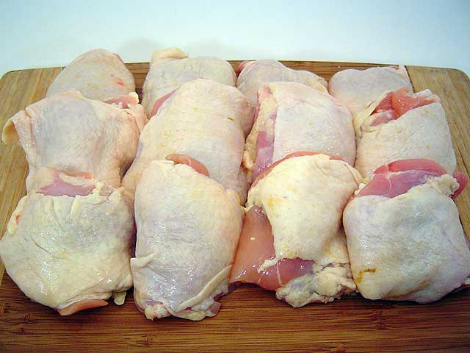
From looking at the thighs, I can see that the skin on the 3rd thigh from the left in the front row is useless. There will not be enough skin to cover the trimmed piece. Further, thighs 1 and 4 in the front row, and thigh 3 in the second row might have similar issues, but I will not know for sure until I skin them. I will still process all of these thighs because the underlying meat is fine, it is the skins that are problematic.
Remove the Skins
Next, I remove the skins from all of the thighs. I take care during this removal not to tear or rip any of the skins. The skins will be firmly attached to one edge but should be loose on the other edge. I work my fingers underneath the skin and gently pull it off. If the attached side is difficult to remove without tearing, I may use a paring knife to aid in the process. Once the skins are removed, I set them aside and put them back in the refrigerator. After we are done trimming, there is no need to match the skin to its original thigh. You can use any skin from any thigh.
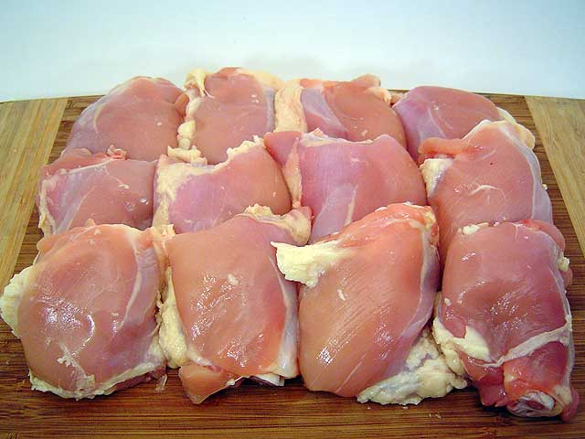
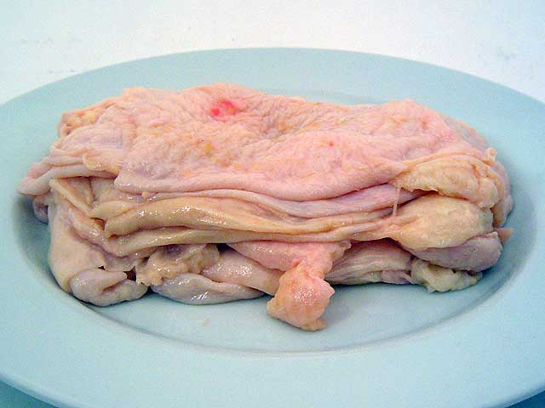
If you are like me and have a propensity to be lazy, you may already be thinking about getting a batch of skinless, boneless thighs and a batch of thighs with skin to save the time and effort of boning the thighs. The idea has merit and if you do not mind the additional expense it can work. But, we prefer to bone our own thighs because the butchers and automated boning equipment are not nearly as careful.
Remove the Bones
After the thigh has been skinned, I remove the bones. To do this, I use a boning knife. A paring knife can also be used as well as a chef’s knife or even a Santoku knife, but the boning knife seems to work best. I lay the thigh skin side down on the cutting board and cut along the bone. Regardless of the knife being used, the job is a whole lot easier if it is sharp. I regularly sharpen and hone the blade I am using during the trimming I then peel the meat back enough to expose the bone. Once this is done, it is a matter of working the knife around the bone to separate the meat. Do not worry about chunks of cartilage being left on the meat because we’ll trim those off next. Of course, the one thigh I chose for these pictures has an abnormal amount of blood or marrow in the flesh around the bone. This is unusual and if I was prepping these for an actual contest, I would probably toss this thigh out so a judge doesn’t end up with discolored or tainted meat.
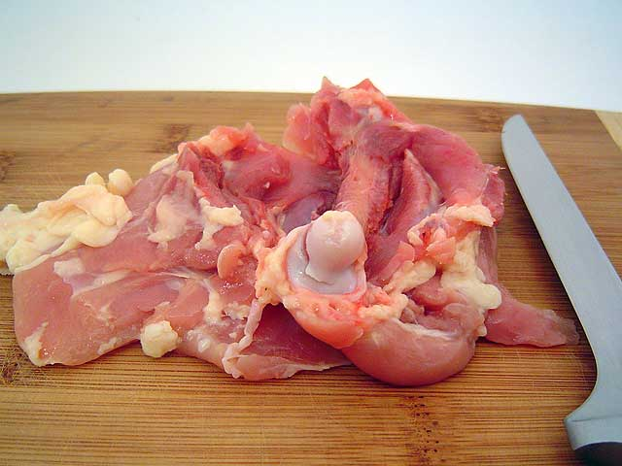
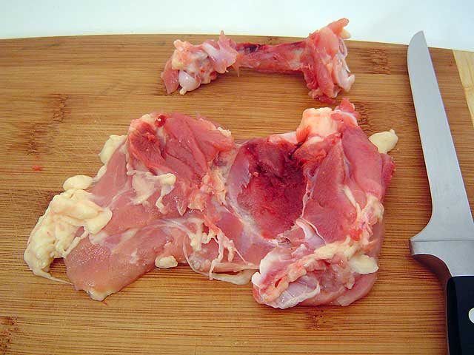
Trim the Thighs
Once the thigh has been boned, I trim the remaining meat to contest specifications, thin, short, and narrow. The goal is to get all of your thighs trimmed consistently and trimmed small enough so that the skins wrap around both edges and both ends. Trim the edges and ends so you end up with a small rectangle. Then I trim for thickness, removing or cutting any thick chunks. I do not have precise specifications but once you go through the whole process a time or two you will know how small these need to be. I do not go out of my way to remove any pockets or strands of fat. These thighs will be plenty lean and will benefit from any leftover fat. The fat will render and add flavor and moisture to the end product.
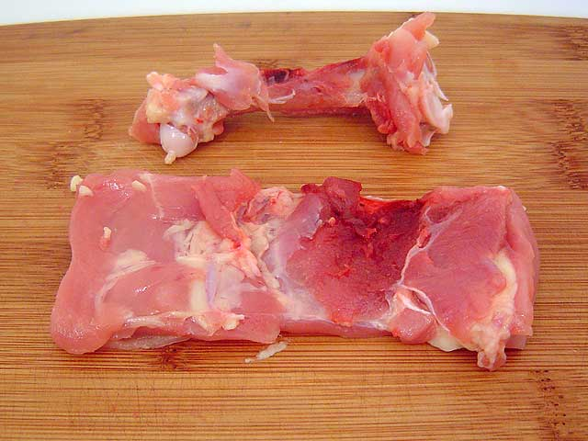
The first picture below shows the 12 thighs trimmed. As you can see, a couple of them have a little triangular shape rather than a pure rectangular shape. From a consistency standpoint, these are less desirable and re-enforce the need to prep at least 24 thighs for a contest. The second picture shows a fairly good looking trimmed thigh. I do not worry about a little meat sticking out of the edges as it will look just fine when finished.
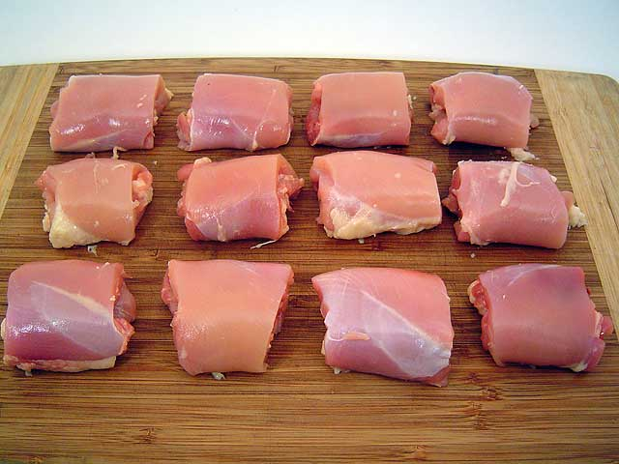
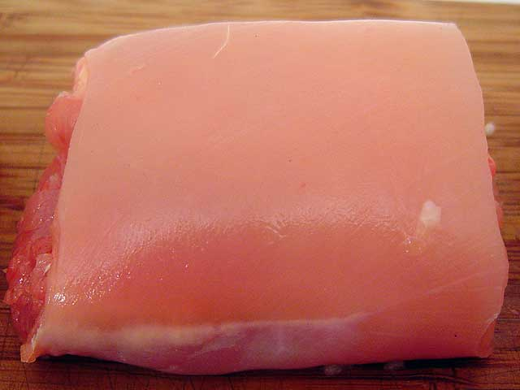
Scrape the Skins
Once the thighs have been trimmed it is time to get the meat back into the refrigerator or cooler and focus on the skins. Chicken skin is one of the most important factors for success. Everyone knows that traditional BBQ cooking results in rubbery, chewy skin. Not addressing skin issues properly usually results in the entire skin coming off the thigh with a judge’s first bite. KCBS rules do not require skin on the chicken but they do require the judges at least taste the skin if it is turned in with the skin on. I am not aware of anyone having consistent success with skinless chicken so it is important to get the right texture.
The holy grail of BBQ chicken is “crispy” skin. I think that is because we all like and are familiar with fried chicken. We have experimented with a couple of advanced techniques using breading or baking soda in order to get crisp skin. While those do produce crisper skin, the negatives of those techniques seem to outweigh the positives. For the most part, the only way to get crispy BBQ skin is to burn it and that is unacceptable in a contest. You will get more sleep if you accept the notion of crispy skin is mostly unattainable and shoot for bite through skin instead. Our goal is to make the skin so tender that a judge can take a bite of one of our thighs and not even notice the skin.
Chicken skin is mostly fat. And it is hard to get that skin fat to render on a smoker or grill without scorching the outside of the skin. Our cooking technique has been adjusted for this, but our preparation technique is the real key to good skin. We simply remove the fat from the skin. This can be accomplished by using a very sharp knife or a cheap, single blade disposable razor. Our favorite tool is a 7” Santoku knife. Regardless of the tool being used, this process requires some practice to get consistent results. Take a sharpened knife and lightly score the internal side of the skin. Then scrape the knife across the skin to remove the fat. It will take several passes of the knife to do this. You will need to get a feel for the right blade angle and the right amount pressure to remove the fat without ripping or tearing the skin. Small tears or holes are not a big problem as the seasoning, cooking process, and sauce will mask them.
It is okay to trim any strings off of the corners, but do not trim any size from the skins. You want the skin to be as large as possible and ideally, it will wrap around the trimmed thigh completely and overlap itself. This keeps the thighs from opening open when cooking and handling.
Once you start scraping chicken skin, you will see exactly how fatty the stuff really is. From the 12 thighs I prepped for this guide, I removed more than 1 Cup of fat from the skins. Frankly, it is a gross process that I take no pleasure in doing. But it is important to the finished product. The goal of this part of the process is to end up with chicken skin that is slightly thicker than sausage casing. If done correctly, the skin becomes translucent. The first picture below shows a skin that has just been scraped. The second picture is of that same skin wrapped around a lime to give you an idea of how translucent it actually is (note the green color showing through the skin). The third picture is of the 12 scraped skins back on the plate. You can see how thin they are compared to the skins before they were scraped (above).
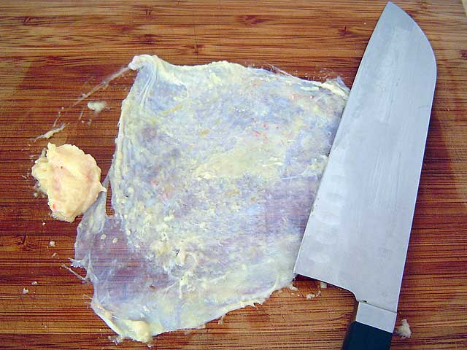
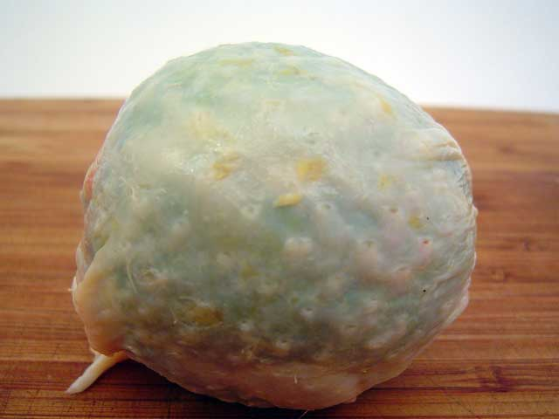
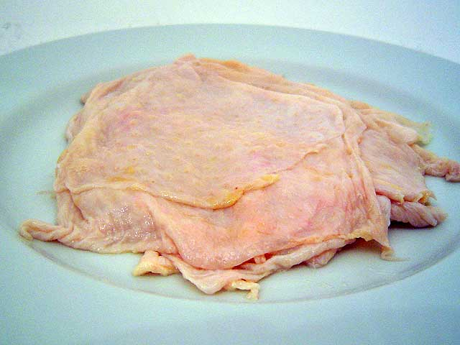
Season the Thighs
Once all the skins are scraped it is time to apply our first coat of seasoning. We use Cimarron Docs Sweet Rib rub for all but the final seasoning. Keep in mind these are small pieces of chicken and a little seasoning goes a long way. Also, the seasoning I apply at this stage will be underneath the skin and will not fall or cook off. I sprinkle a little on each side and pat or lightly rub it into the flesh.
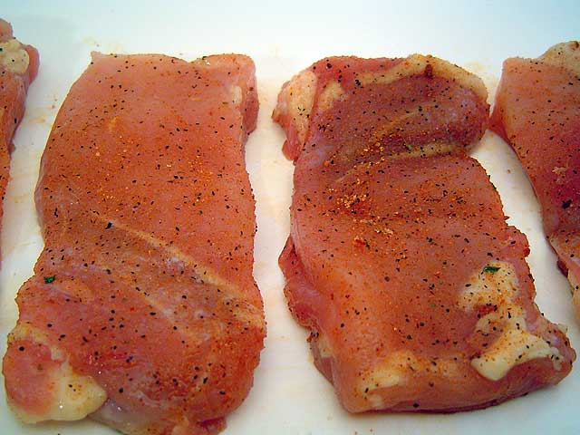
Shape the Thighs
Next, I tri-fold my seasoned chicken pieces into a thigh like shape. Both ends should be tucked underneath and the skin side of the thigh should be exposed. The finished product will not look very good if you fold them inside out or just fold them in half with the ends on one side.
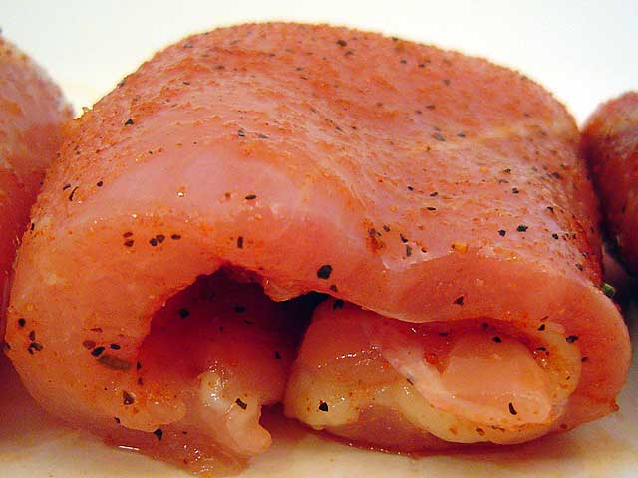
Put the Skins On
Then I carefully wrap a scraped skin around each thigh. I make sure and place the fat side of the skin on the meat, just like nature intended. Cooking the skins inside out does not work well. Ideally, each skin will wrap all the way around the thigh and overlap on the bottom. If a skin is really large, I overlap an edge around the side or top. The thin skin layers will fuse during cooking and the seam will not be noticeable. And as long as the skin overlaps, the thighs will stay tight during cooking and handling. For those pieces where I do not have enough skin to completely wrap a thigh, I have to be extra careful during cooking because the thighs tend to open and skin may shrink or peel off. Once the thigh is wrapped, I season it again with Cimarron Docs on all 6 sides.
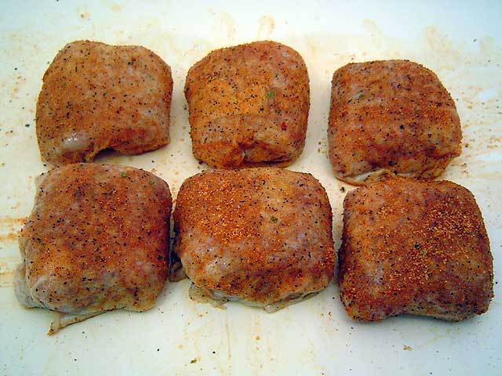

Part III Cooking

Timing is critical for the chicken category. Ideally, I want to take the chicken off the cooker and place it directly into the box and get it turned in with little delay. This is why consistency in all aspects is important. Our small chicken thighs cook quickly and there are several steps in our cooking process to cram into a short time.
The process needs to be adapted for the type of cooker you are using. Last year, we used an offset stick burner and Weber Kettle for chicken. This year, we are using drum cookers for chicken and we had to make some adjustments. The four basic steps are: 1) braise in margarine, 2) cook bottom side down to set the shape, 3) cook top side down, and 4) finish over high direct heat to fully render skin. The actual time for each step will depend on your cooker so you can use our timeline as a guide but be prepared to adjust.
For smoke flavor, we use 2 parts cherry to 1 part hickory regardless of the cooker being used.
Braising In Margarine
A little contest secret that is often whispered about but rarely shown involves the “magic blue bottle”, or Parkay Margarine. While it is sold in blue squeeze bottles, we find it cheaper to buy the big tubs that seem to work just as well. Braising the thighs in margarine adds a rich buttery taste to the chicken and it also keeps the thighs tender and juicy.
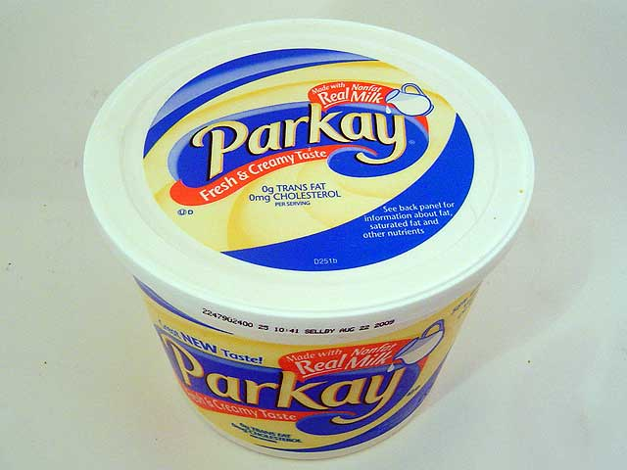
I place about 1/3 of a tub of margarine in an aluminum pan and stick it in a cooker so it melts. I sprinkle a little more Cimarron Docs in the melted margarine. Then, I place the seasoned thighs bottom side down into the margarine. 12 pieces will fit in a single pan. I do not want to completely submerge the chicken thighs, only the bottom half or so of each thigh should be in the melted margarine. Keep in mind that as you add the thighs to the pan, the level of the margarine will rise.
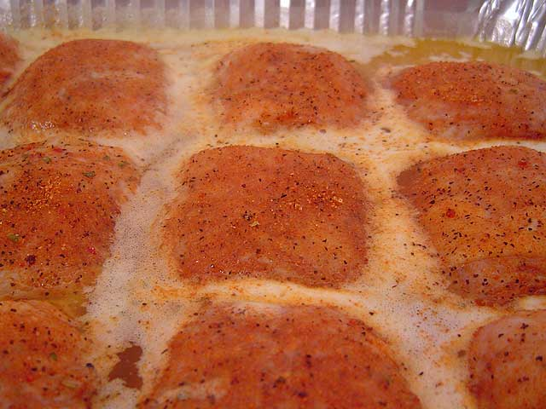
Place the pans onto the cooker. In our offset, we placed the pans in a zone where the temperature ran about 250F and we would let them braise in the pan for about 30 minutes. In the drum cookers we now are using, I put the pans on at 250F but then start opening up the vents and let the temperature rise towards 325F. And after 10-15 minutes at these higher temperatures, it is time to remove from the pan. The lower the pit temperature, the longer you can braise the thighs.
If you look carefully at the upper right corner of the first picture below, you can see a naked thigh resulting from the skin that was too small to use. Even though not suitable for an entry, I’ll cook it anyway and use it to sample the flavor.
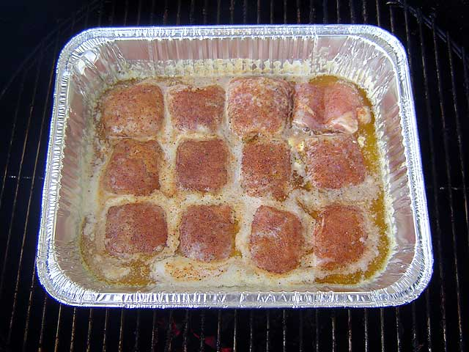
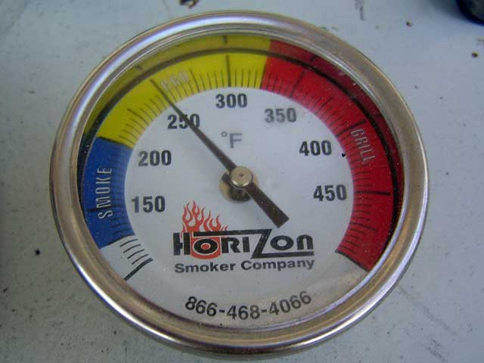
Set the Shape
When I first remove the thighs from the margarine pan, they are very tender and pliable. I have to be careful not to move them too much or they tend to lose their shape. Using gloves or tongs, I gently place each thigh bottom side down in the cooker. At this point, I lightly re-season the thighs with Cimarron Docs again. In our offset cooker we had the chicken in a zone that ran at about 275-300F and cooked it for about 15 minutes in this stage. On the drum, the temperature is about 300F on its way to 325F and this step only lasts 7-10 minutes.
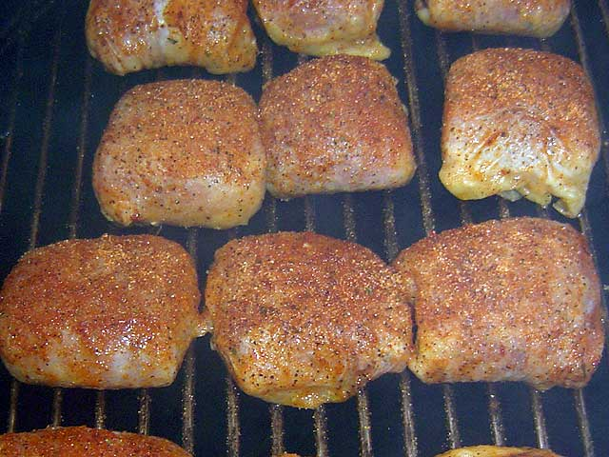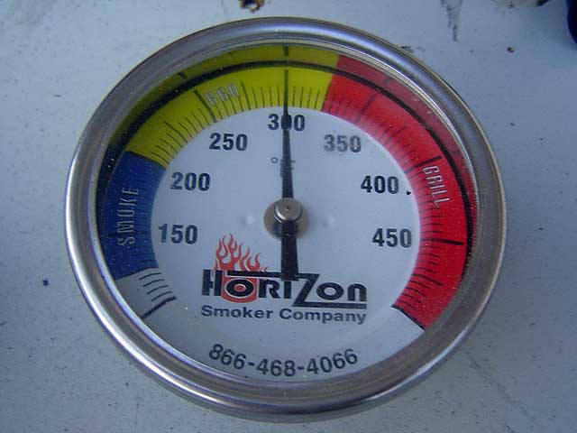
Continue Cooking and Finish Over High Heat
As soon as the pieces firm up a little, it is time to flip them over so the top side is facing down or closest to the heat source. The thighs should be firm enough at this point to hold their shape as long as they are handled carefully. In our offset cooker, we placed the chicken in a zone that was 300F and we would cook them until the internal temperature was 150-160F (about 25 minutes) before moving them to a direct heat grill to finish. Once on the grill, we had to continually flip the thighs to prevent scorching. A few grill marks add character but it is really easy to burn the skin when cooking at a high heat. It would take two of us armed with gloves and tongs to work the chicken on the grill. The goal is to cook each piece so the skin is fully rendered until an internal temperature of 175F is reached (about 10 minutes on the grill).
On the drum cookers the grill temperature is about 325F at this point. We just leave them face down until the tops of the thighs have the color we want or the internal temperature is 175F (about 25 minutes). If the tops get our desired appearance early, we flip them and finish cooking the thighs face up. It does not matter what the bottom of each thigh looks like as the judges will not see it. We really focus at keeping the skin on the tops looking good.
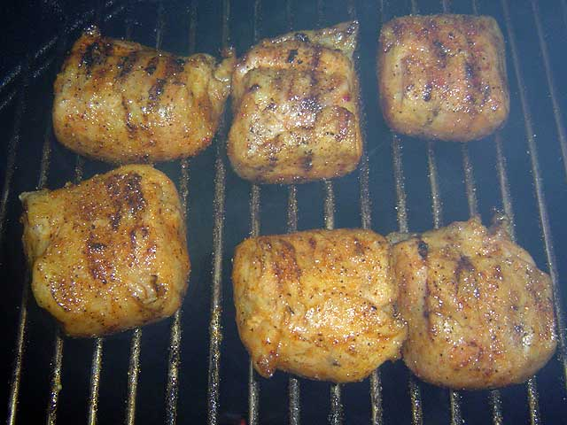
If you have been keeping track of these times, you will notice the cooking process time on our offset and kettle combo was about 80 minutes. On the drum cookers, we are getting through the entire cooking process in about 50 minutes. Keep your Thermapen handy and adjust the timing as needed.

Part IV – Final Touches and Presentation

Right after we start cooking the chicken, we mix and heat our contest sauce. We use equal parts Blue Hog Original and Blues Hog Tennessee Red and mix a little pineapple juice concentrate. I would give you the exact measurements but we do not really measure the ingredients. The mix is formulated on taste. A rough estimate is 1 jar BH Regular, 1 jar BH Tennessee Red, 1/3 can pineapple juice concentrate.
When the chicken is done cooking, each piece is taken off the cooker, dunked in the sauce, and set on a cutting board. We then dust the tops ever so lightly with finely ground Smokin’ Guns Hot rub. The fine grind just disappears into the sauce and the judges are none the wiser to this last minute enhancement.
As we are dunking the chicken, we feel each piece to check for tenderness of the meat and the skin. Once you do this a couple of times your fingers will know when a piece has been properly cooked. Any rejects are set aside. Then, it is a matter of selecting the best 9 pieces for the clamshell and arranging them into 3 rows of 3 pieces. We’ve put as many as 12 in the box before but our appearance scores seem to be higher with only 9 pieces. We use putting greens as garnish for all of our boxes.
Once the pieces are arranged in the box, we spritz the top with warm water, wipe down the edges of the box, take a couple of pictures, and get the entry to the judges. We take no more than 5 minutes from the time the chicken comes off the cooker to the time we’re walking it up.
Here are a couple of pictures of the chicken after it was removed from the cooker but before being sauced. I really like the color.
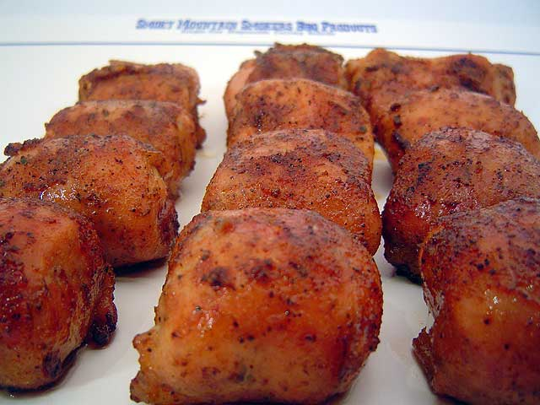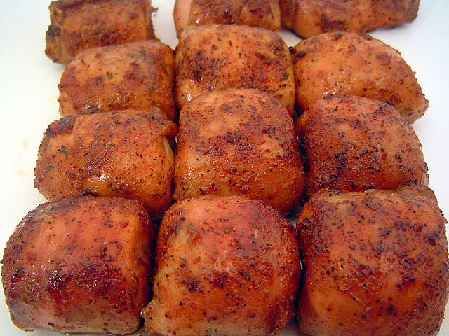
And here are a couple of pictures of the same chicken after it was sauced and seasoned.
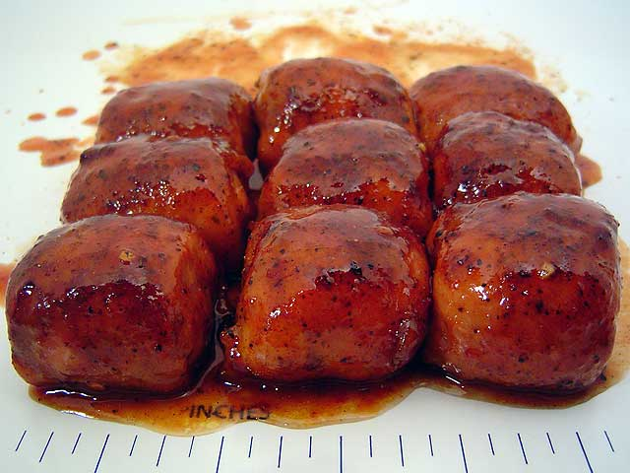
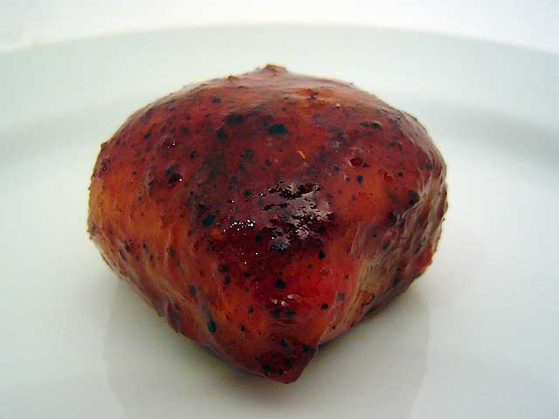
Last Minute Corrections
Since we try and time everything so closely, there is only so much we can do once the chicken is done. If the chicken is done early, place the un-sauced thighs in an aluminum pan with a small amount of margarine, cover with foil and hold over low heat. If the chicken is under seasoned, add more finely ground Smokin Guns. If it is over seasoned, dunk the thighs in the sauce again and try and to rinse some of the seasoning off. If the chicken is overcooked and you have time, try melting a little of the margarine and injecting it into the thighs. If the chicken is undercooked (monitor as you cook it), crank up the heat and get it done, even if it means charring the skin a little. The worst possible thing you can turn in is undercooked chicken. Undercooked chicken is tough, does not have that rendered fat flavor, and is a health hazard to those eating it.

Chicken Entry Pictures

I have included pictures of some of our recent award winning chicken entries below. I also included our 6 judge average appearance score and the place it finished in the contest. Keep in mind that in KCBS judging, the lowest overall score is dropped and that usually results in a higher 5 judge average score. When we get over 8.0 in a 6 judge appearance average, we seem to do well come awards time.
2008 Lawrence Contest
Place – 3/48
Avg. Appearance Score – 8.50
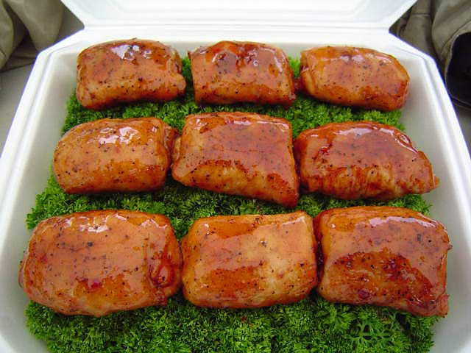
2008 McClouth Contest
Place – 10/39
Avg. Appearance Score – 8.00
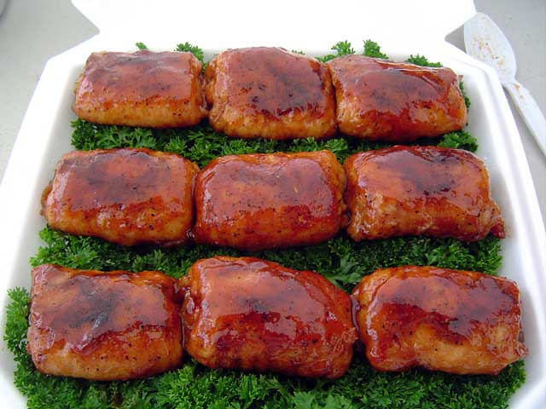2008 Lincoln Contest
Place – 6/27
Avg. Appearance Score – 7.50
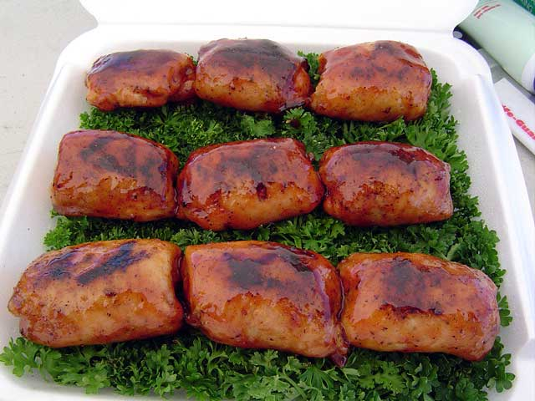
2008 Excelsior Springs Contest
Place – 7/71
Avg. Appearance Score – 7.83
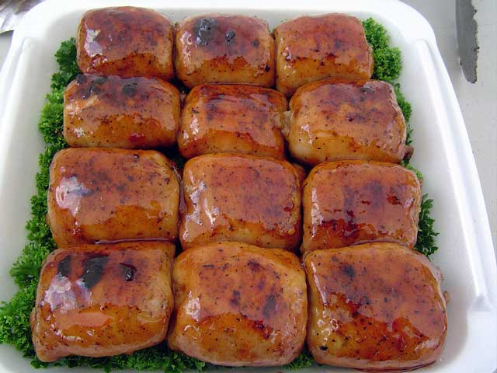
2008 Leavenworth Contest
Place – 3/29
Avg. Appearance Score – 8.50
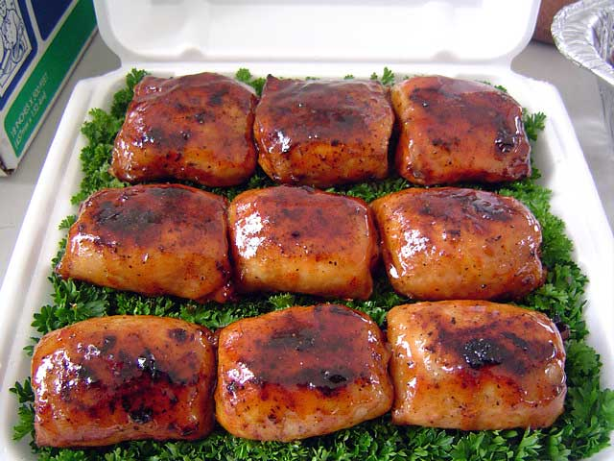
2008 Crosspoints Contest
Place – 10/27
Avg. Appearance Score – 7.50
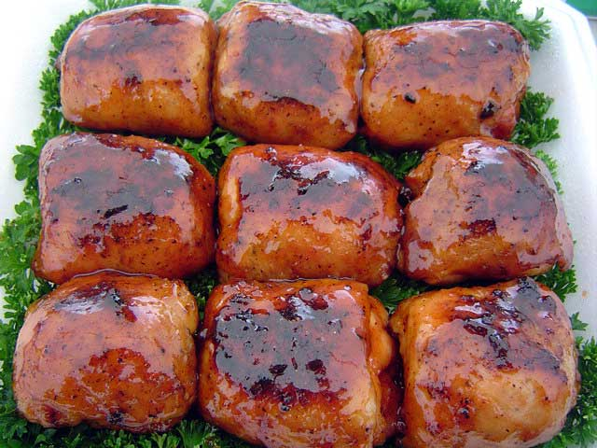
2008 Kearney Contest
Place – 1/35
Avg. Appearance Score – 8.17
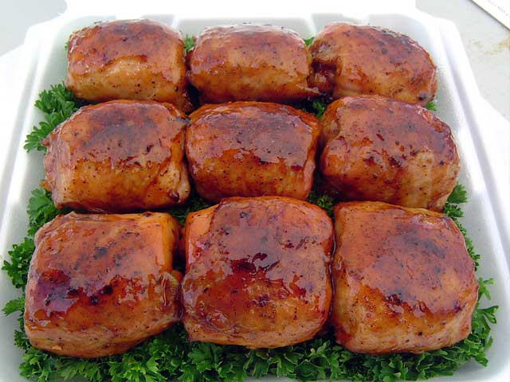
2008 American Royal Contest
Place – 110/459
Avg. Appearance Score – 8.50
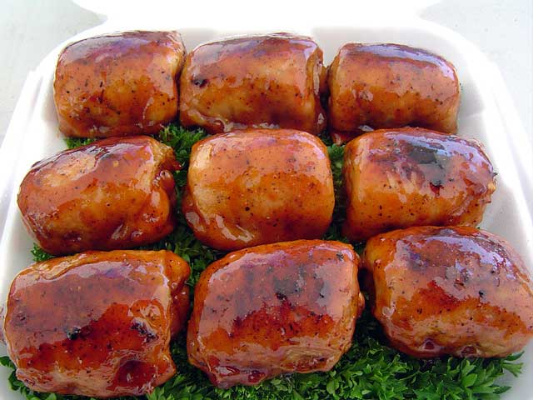
2009 Jack Daniels Backyard BBQ
Place – 1/12
Avg. Appearance Score – 8.33
