How To Make A Parsley Bed

Like it or not, good garnish techniques can really help appearance scores at a KCBS contest. Although the judges are not supposed to judge your garnish, they do. All of the top teams I am familiar with use garnish so there must be something to it. And, if you read some of the judging comments on other forums, it is quite apparent that garnish will influence your scores.
Our goal in presentation is to highlight the entry. We want the garnish to help the judges focus on the entry, not distract them. If successful, the judges will look at the meat instead of the garnish or lack of garnish. To accomplish that, we try and make boxes that are balanced and symmetrical. The greens should frame the entry but never obscure it.
For our first 6 years of competing, we used lettuce beds and sometimes accented with parsley. Our presentation scores were consistently mediocre with occasional high points. Once we started using parsley beds in the entry boxes, our appearance scores improved dramatically. We frequently average over 8 on appearance for our entries and have scored the occasional all 9's in appearance since we started using parsley beds.
I wish we had learned about parsley beds sooner in our competitive career. One of the reasons we operate this site is share information so it only seems fitting to start the conversation here. There are other techniques and some may be quicker and better. Please feel free to share your experience.
1) The hardest part in making a good parsley bed is finding good quality greens. Good looking curley parlsey in particular is difficult to find. We sometimes go to several supermarkets before finding the right stuff. We typically use 2 small heads of green leaf lettuce and 3-4 bunches of curley parsley per box. When selecting parlsey, look for bunches that contain a lot of really curley (think frilly) leaves as opposed to flat leaves.
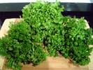
2) Cut the green leaf lettuce head into 3/8" strips. Try and keep the round disc shapes intact as it is easier to place in the box.
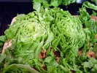
3) Place as many of those discs into the bottom of the styrofoam clamshell as you can. Pack them tightly with the edges vertical.
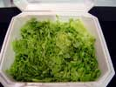
4) Cut off your choice parsley heads (curley and consistent in color) with a 3/8" stem. Place the stem in between edges of your lettuce bed. Pack the parsley in as tight as you can, keeping the height about 1/4" below the lip of the clamshell. Loose parsley will not support your meat and may stick to it when the judges pick it up.
This part takes a lot of time. Plan to spend 30-45 minutes per box, maybe longer at first. It doesn't really matter where you start or finish. Just focus on keeping the tops level in the box. If you see a piece of parlsey that doesn't match in color, or has leaves noticeable flatter, remove it and replace. Focus on the edges and corners of your box since that is what the judges are going to see.
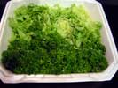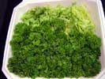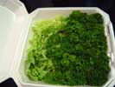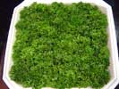
Once your parsley box is complete, place a wet paper towel on top of the parsley and place it in a cooler. Pull it out as you are preparing your entry.
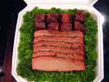

This time with Iceberg Lettuce

In our last contest, a couple of our parsley beds were too high causing our entries to make contact with the top of the box. So I thought I'd experiment a little making a multi-level parsley bed with the center slightly depressed. I decided to try iceberg lettuce instead of green leaf for this experiment because iceberg is more rigid and I figured the lettuce discs could be shortened.
Here's what I did.
I slice 2 heads of lettuce into a few discs that were between 1/4" and 3/8" tall.
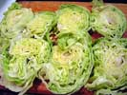
I then crammed 4 of those discs into a clamshell.
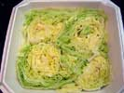
I filled in the parsley bed, using shorter pieces for the center. I also did not fill the center as tight as the edges and corners.
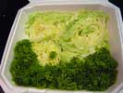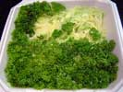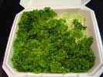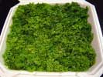
And lastly, I tried it out with some spare ribs.
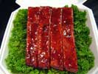
It worked. The lid closed just fine. Although the iceberg is a little harder to work with, it does add considerable weight to the box.

